INFO 6205 ASSIGNMENT3 REPORT

Author: Kaiyuan Zhao

**BenchMarking**

**Hypothesis**:

For this Benchmark test, I used selection sort method and insertion sort method in three different types of Arrays. (Ordered Array, Reverse Array, Random Array). My hypothesis is for the ordered array the insertion sort will be more efficient than selection sort, and for the reverse ordered array, they are pretty much the same, for the random array, the insertion sort will be quicker than selection sort.

**Obervations**:

I implemented two sorted method one is Selection Sort and the other one is Insertion Sort for this assignment. Here are those two screen shots for each sorting methods’ running test.

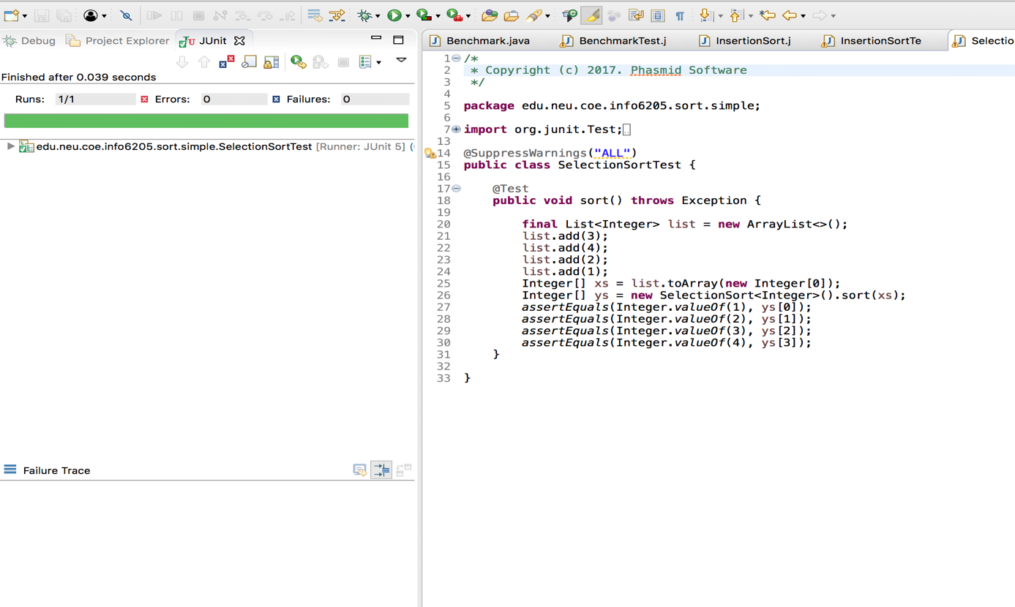

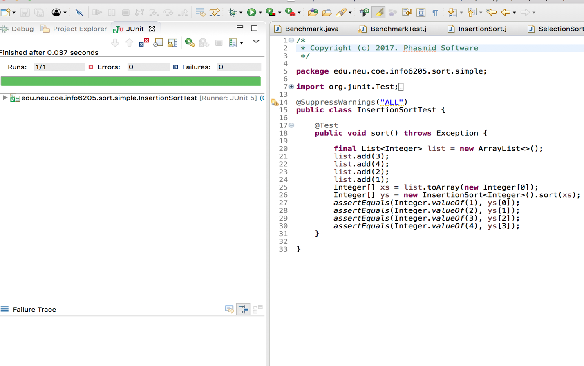 Then I implemented the run method in Benchmark.java class. Here is the screen shot.  
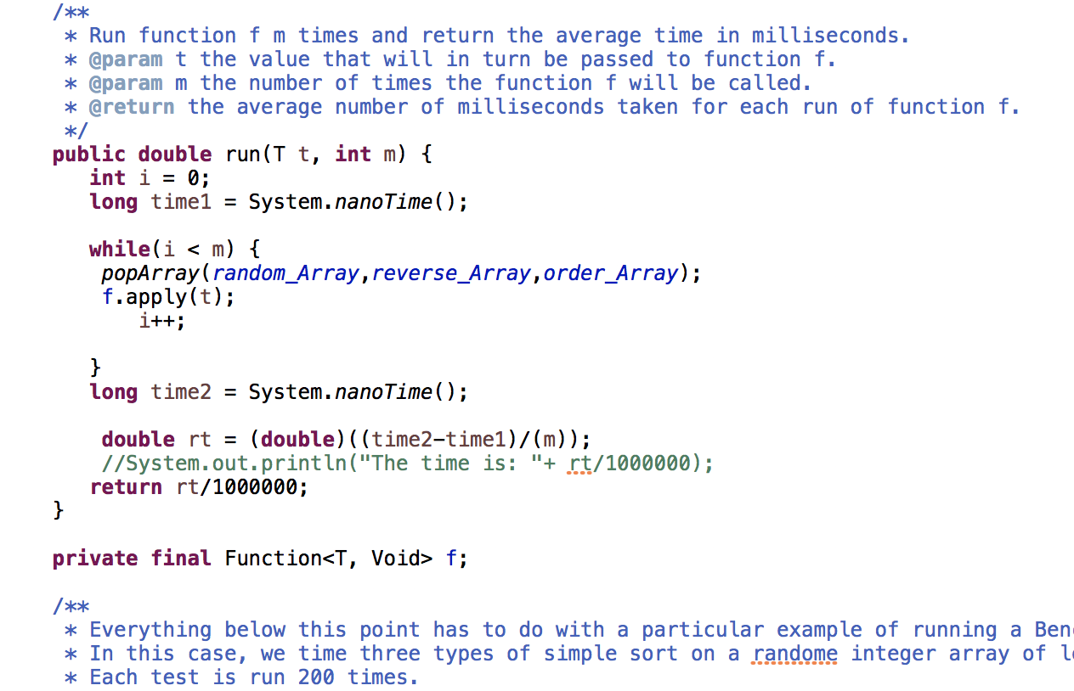

In this method, I added another method which is called popArray, here is the screen shot.

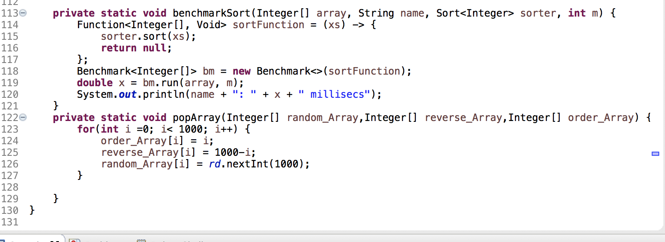

In the popArray method, I picked three different types of array, one is to generate random number array, one is to generate reverse number array, the last one is in ordered array. Compare different sorting time among those different types of array in two sorting method.

Those arrays are declared as the global variables, I can change the array size also, as default, I made it 1000, here is the screen shot.

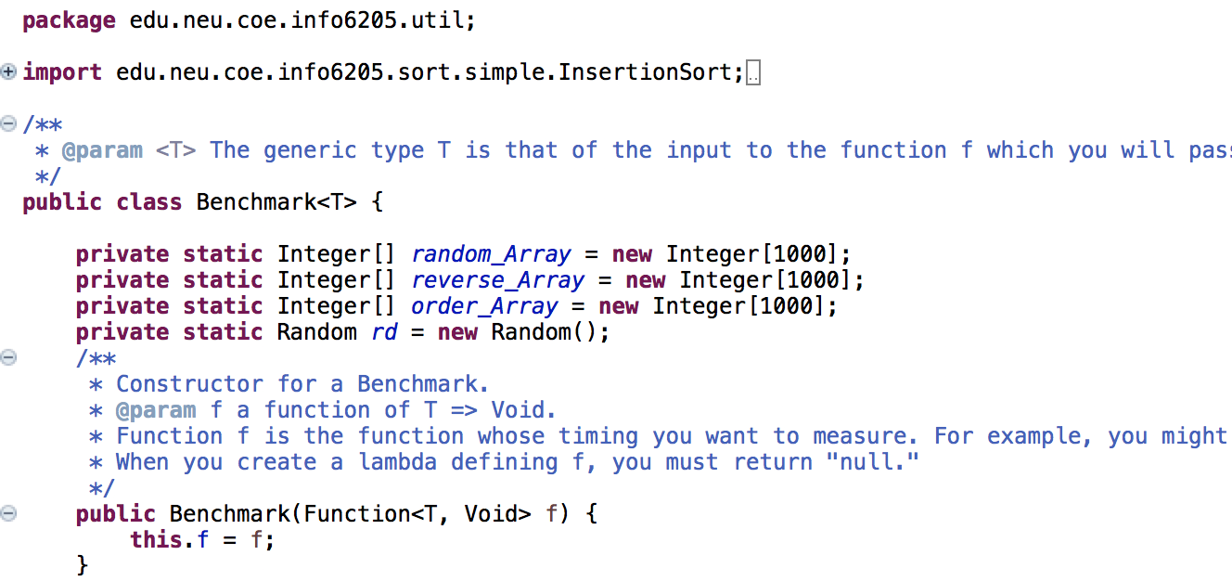

In the main method, I called popArray and benchmarkSort methods to get the output, here are the screen shot for the main method and output.

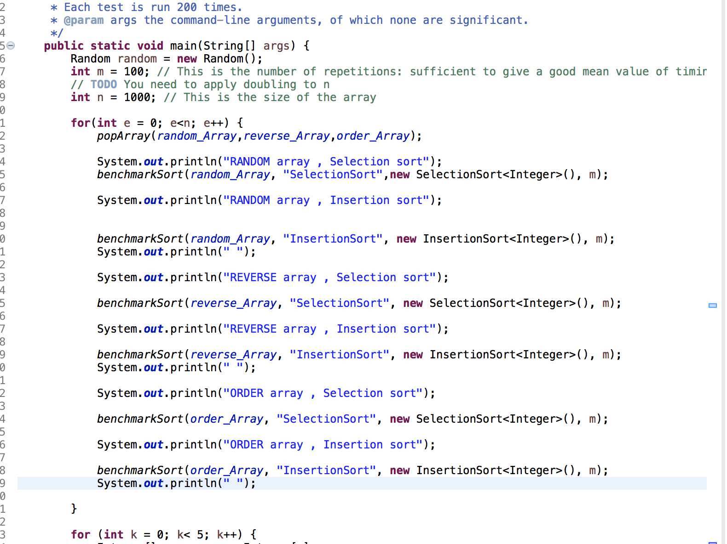

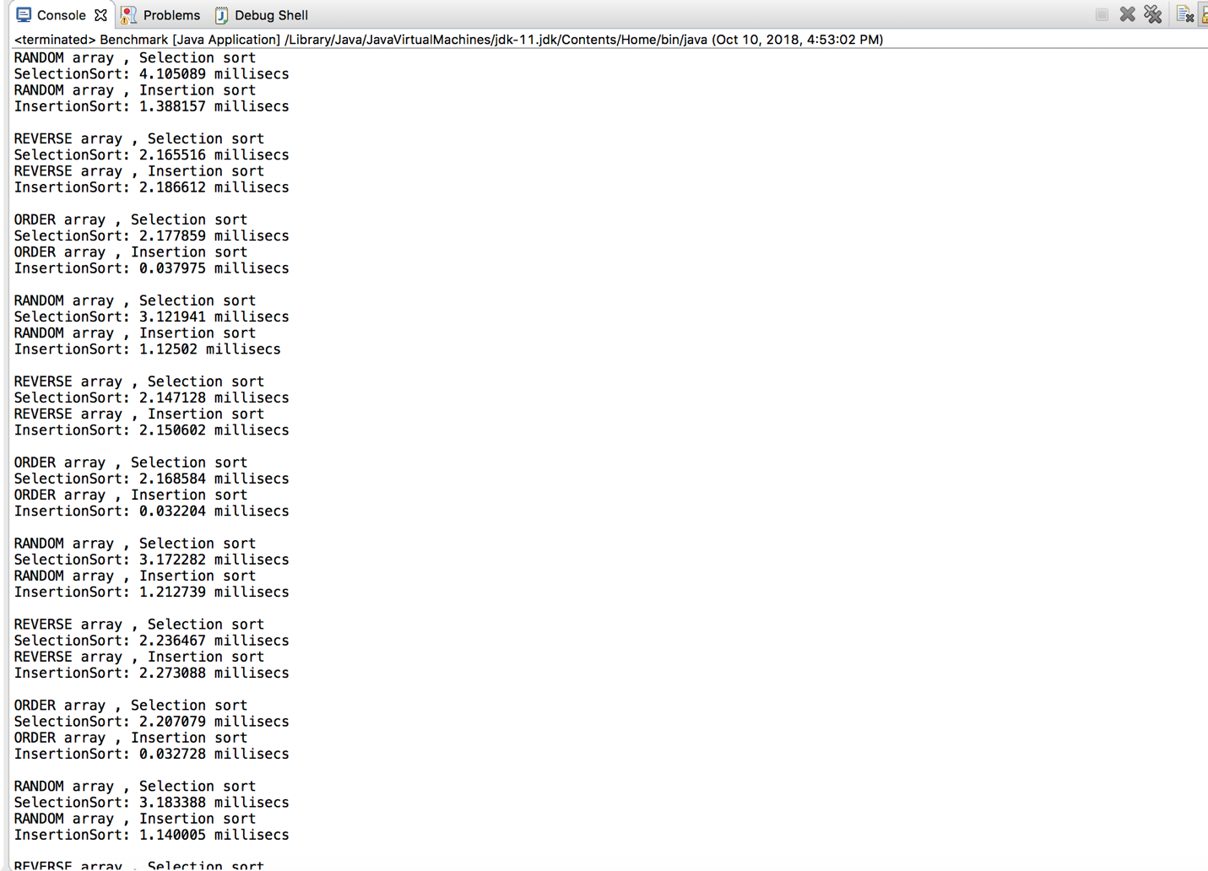

After complete benchmark class, I ran the benchmark test class, but I cannot pass them, here is the test result.

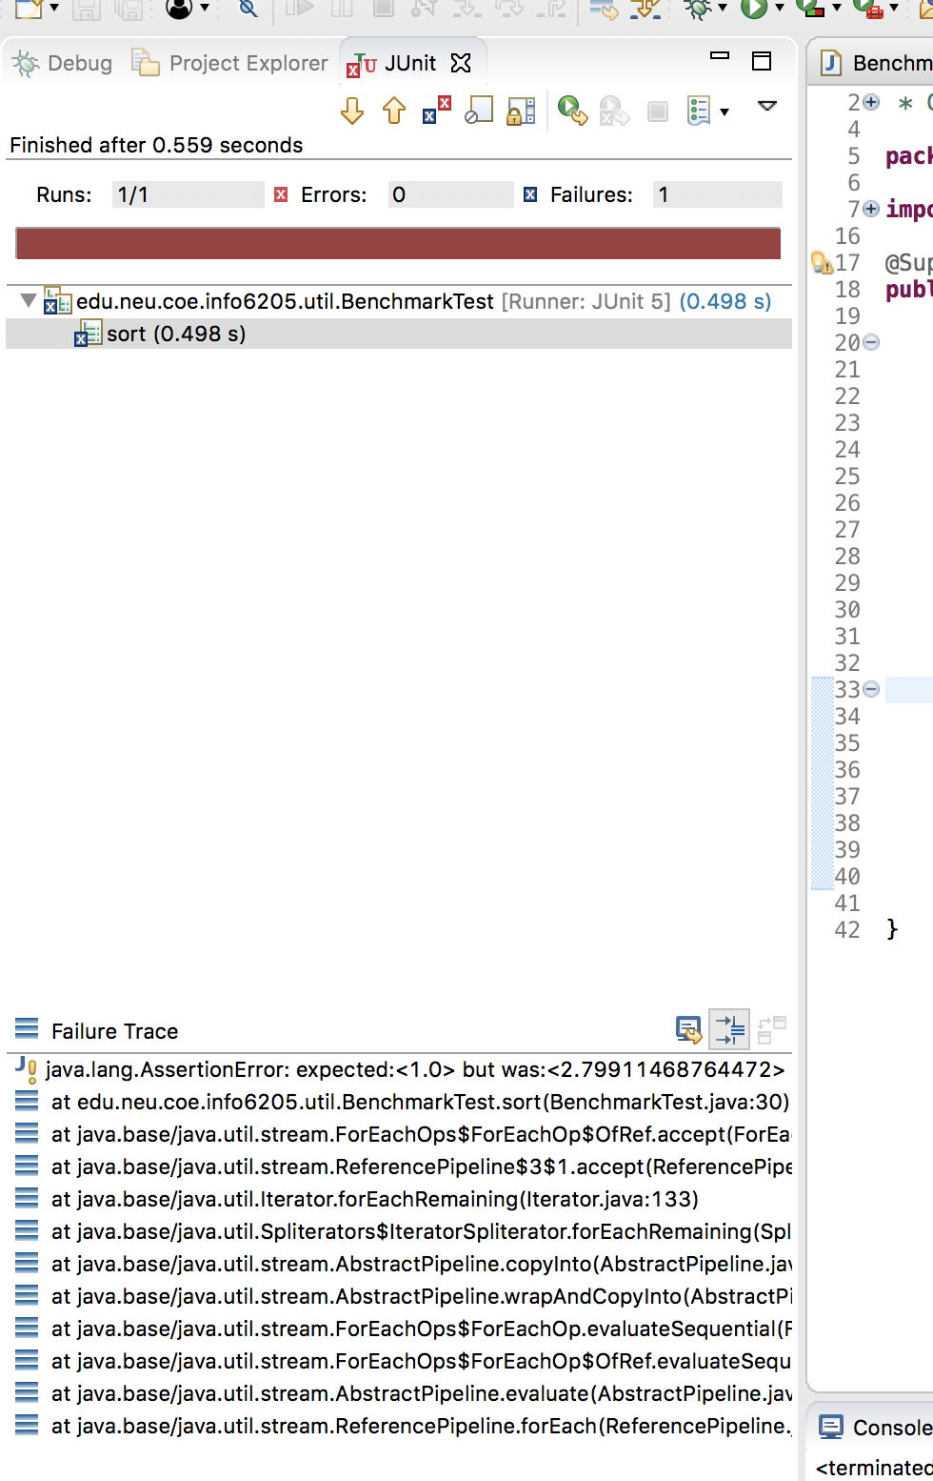

In the excel, I picked 10 sorting cases for each array type and each sorting method, here are the screen shots.

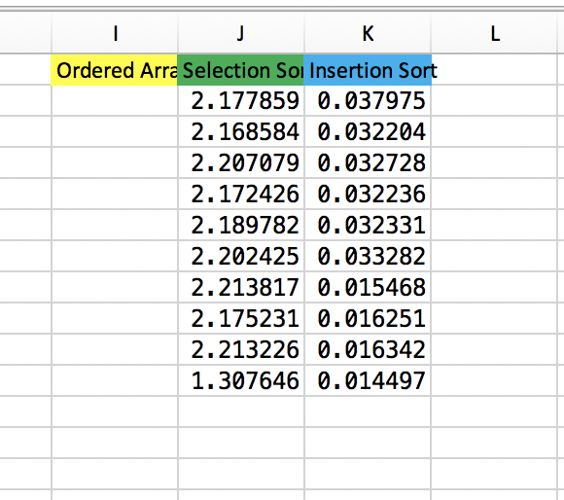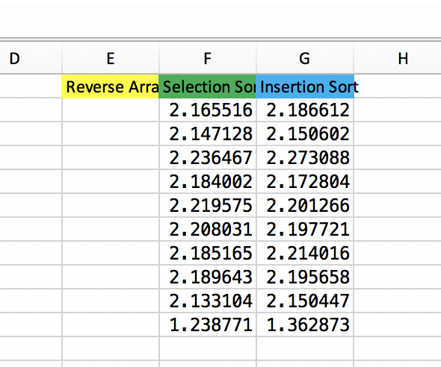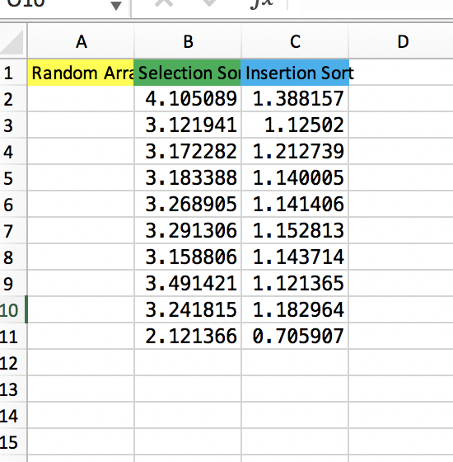

Here are the graphs.

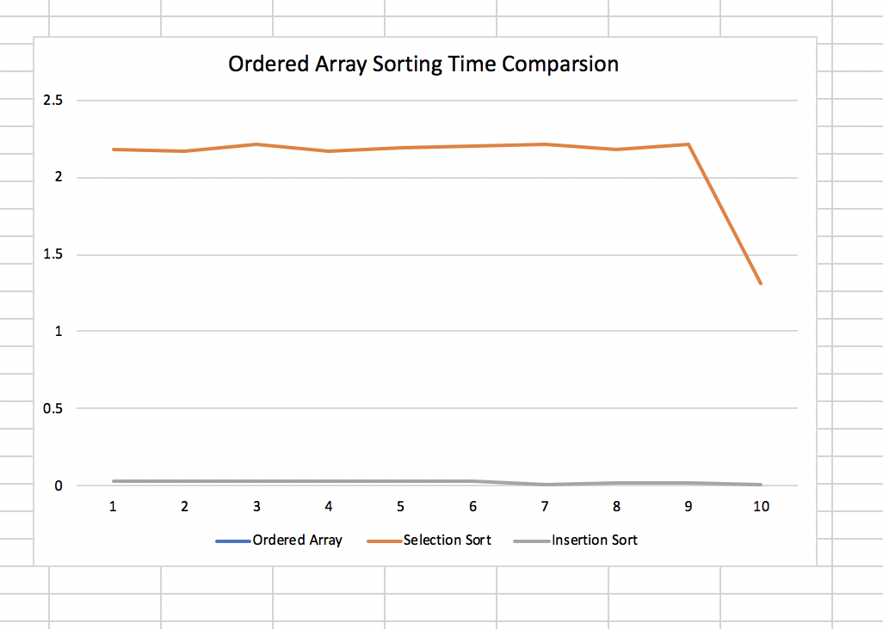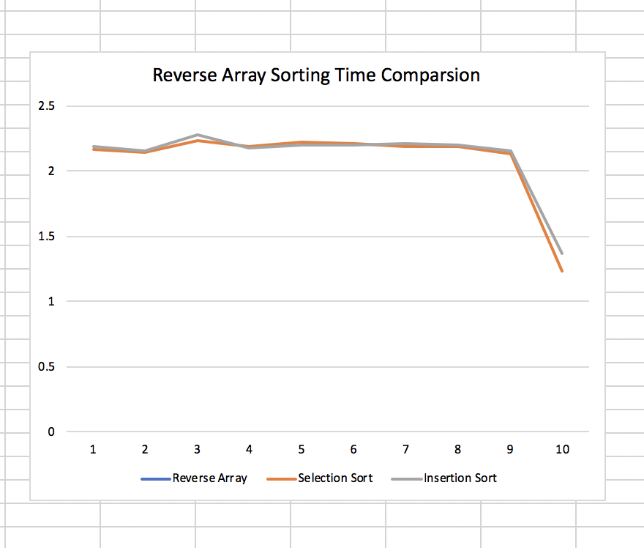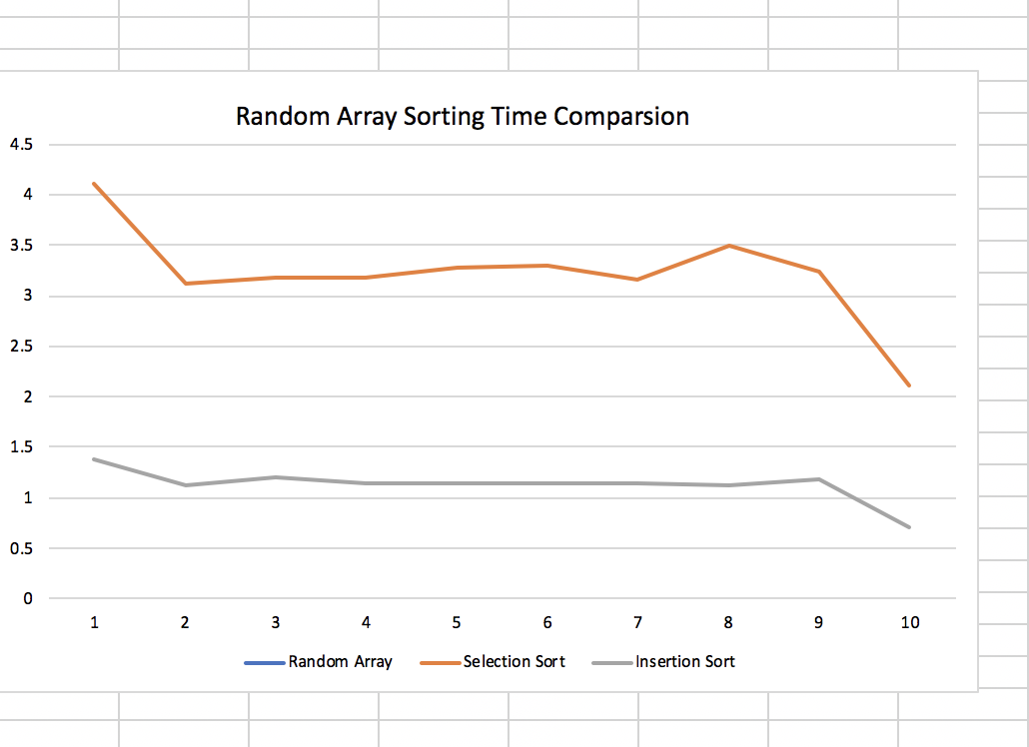

**Conclusion:**

After this experiment, I found out for the Ordered Array, Insertion sort is much quicker than Selection sort, as we talked in class, Insertion sort best case is N, it better use in smaller N or partially ordered arrays. For the Reverse Order Array, Insertion sort and Selection sort are pretty much the same. In the worst case of . For the Random Ordered Array, Insertion sort is also quicker than Selection sort, selection sort with average as , Insertion sort with average as